**WEEK 7 ASSIGNMENT (DIGITAL NURTURE 4.0 JAVA FSE)**

**NAME: JEYAKUMAR R**

**SUPERSET ID: 6396631**

**TicketBookingApp:**

**CODE:**

**App.js:**

import React, { useState } from 'react';

import GuestPage from './GuestPage';

import UserPage from './UserPage';

function App() {

  const [isLoggedIn, setIsLoggedIn] = useState(false);

  const handleLogin = () => {

    setIsLoggedIn(true);

  };

  const handleLogout = () => {

    setIsLoggedIn(false);

  };

  return (

    <div style={{ textAlign: 'center', marginTop: '100px' }}>

      {isLoggedIn ? (

        <UserPage onLogout={handleLogout} />

      ) : (

        <GuestPage onLogin={handleLogin} />

      )}

    </div>

  );

}

export default App;

**GuestPage.js:**

import React from 'react';

function GuestPage({ onLogin }) {

  return (

    <div>

      <h1>Please sign up.</h1>

      <br />

      <button onClick={onLogin}>Login</button>

    </div>

  );

}

export default GuestPage;

**GuestPage.js:**

import React from 'react';

function UserPage({ onLogout }) {

  return (

    <div>

      <h1>Welcome back</h1>

      <br />

      <button onClick={onLogout}>Logout</button>

    </div>

  );

}

export default UserPage;

**index.js:**

import React from 'react';

import ReactDOM from 'react-dom/client';

import App from './App';

const root = ReactDOM.createRoot(document.getElementById('root'));

root.render(<App />);

**Outputs:**

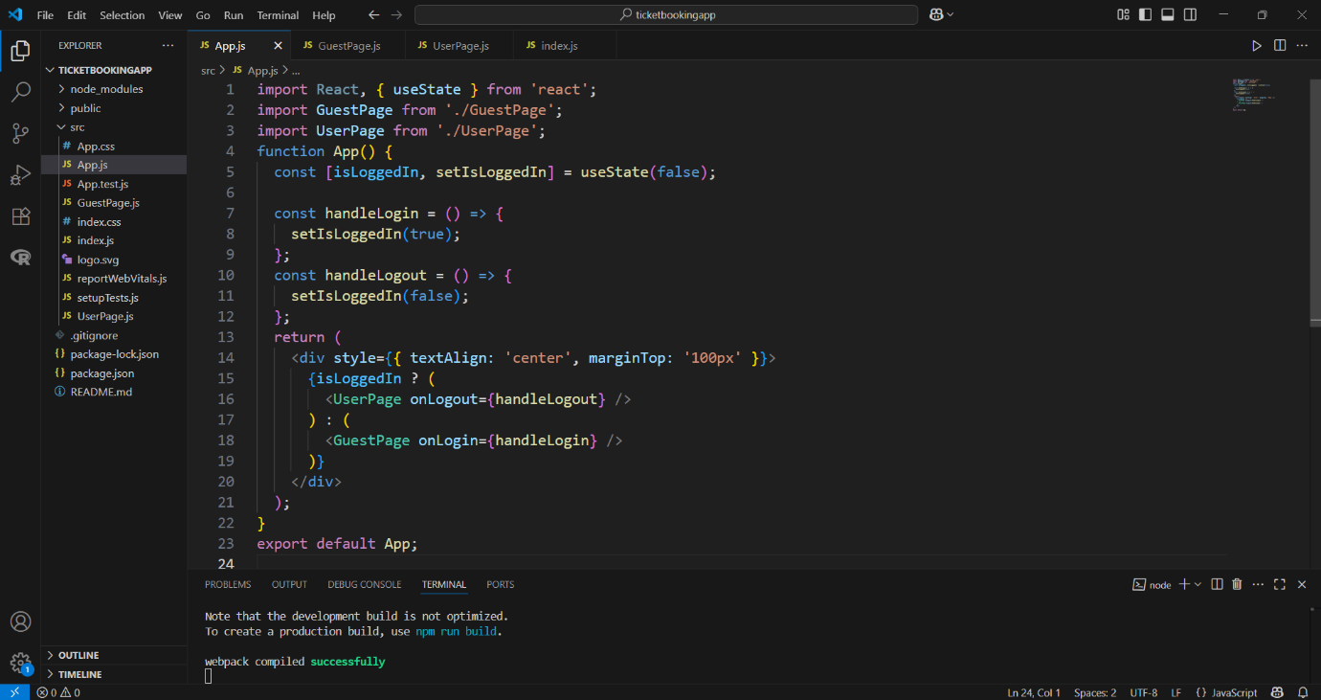

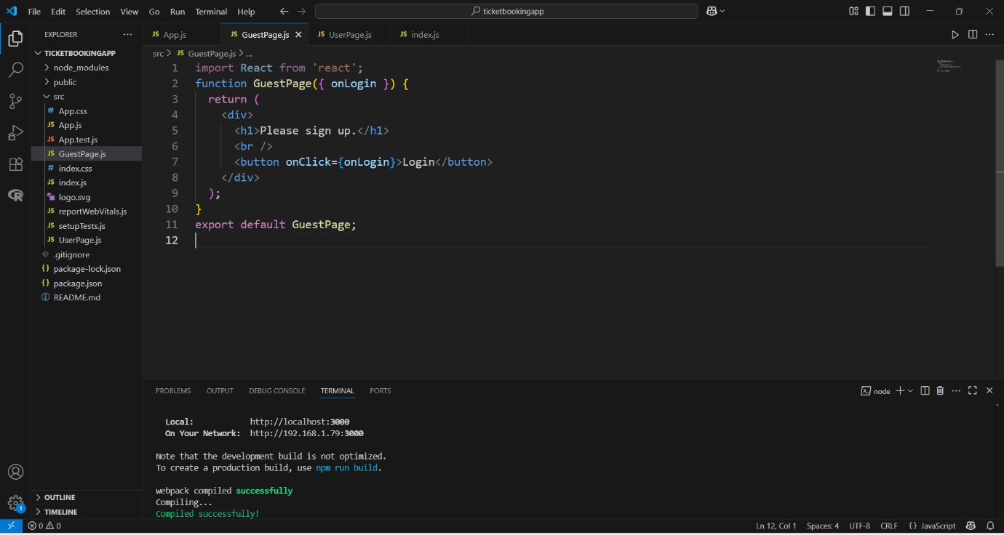

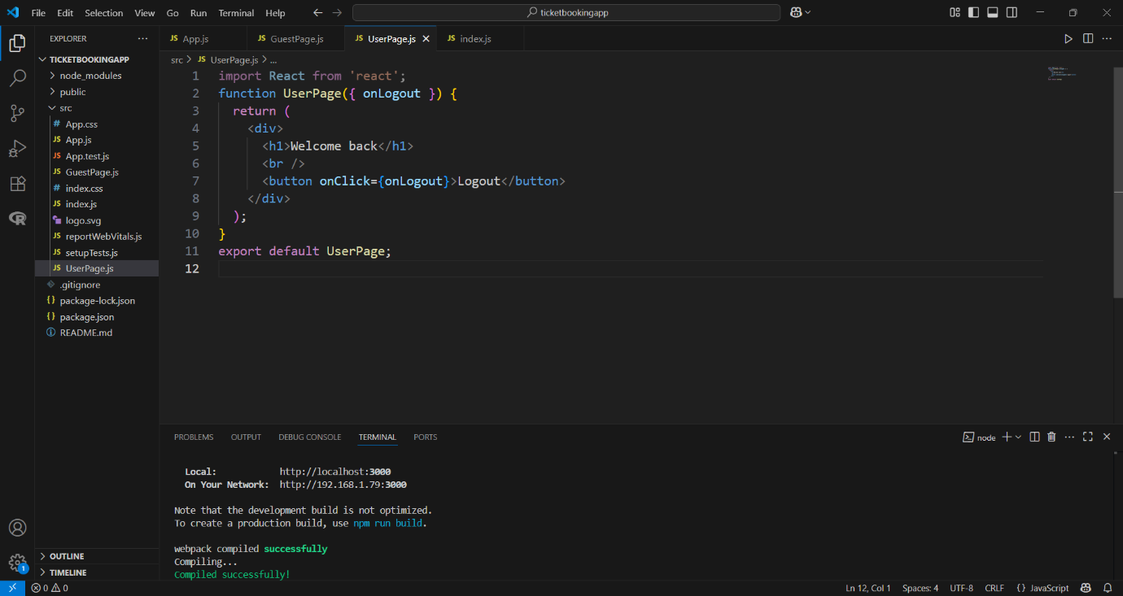

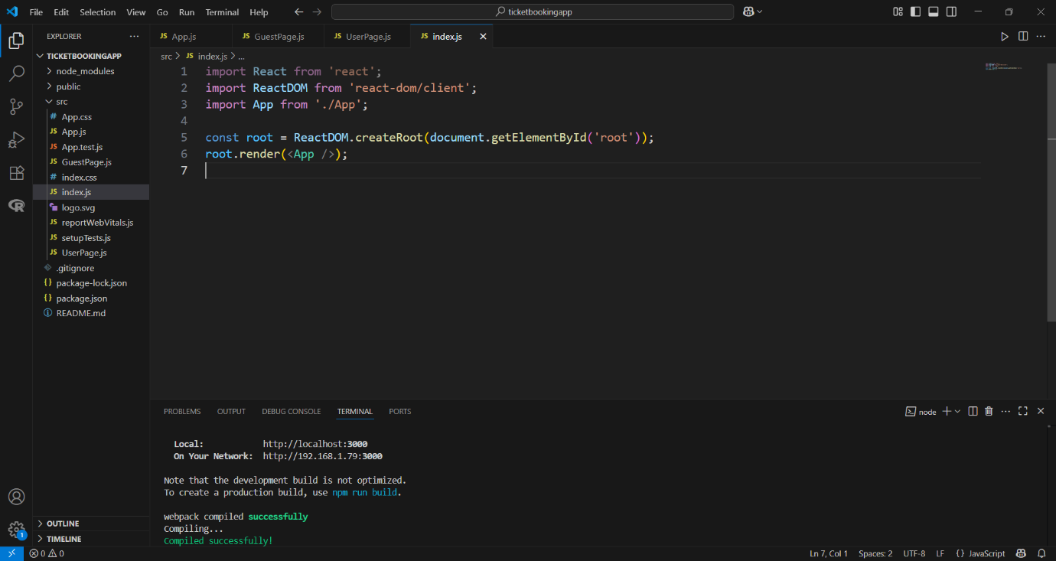

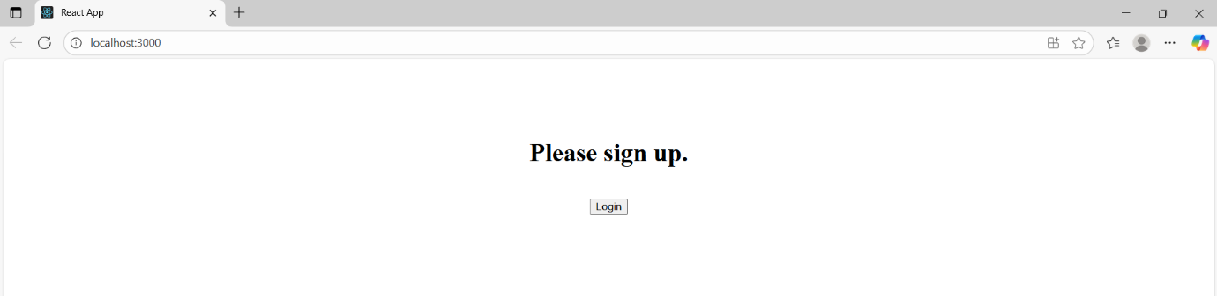

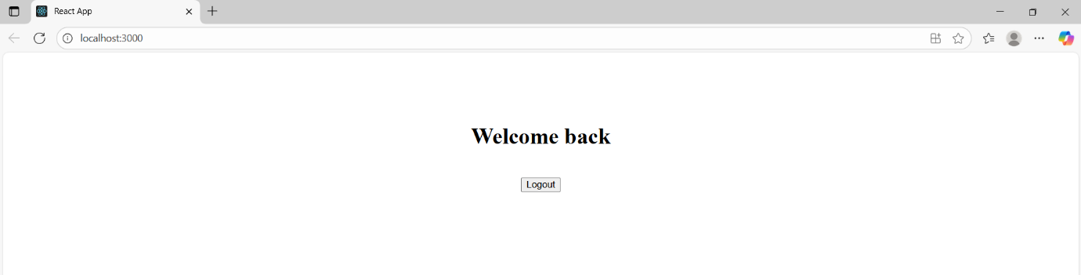

**Cricketapp:**

**CODE:**

**App.js:**

// src/App.js

import React from 'react';

import ListofPlayers from './components/ListofPlayers';

import IndianPlayers from './components/IndianPlayers';

function App() {

  const flag = true; // Change to false to test IndianPlayers

  return (

    <div className="App">

      {flag ? <ListofPlayers /> : <IndianPlayers />}

    </div>

  );

}

export default App;

**ListofPlayers.js:**

// src/App.js

import React from 'react';

import ListofPlayers from './components/ListofPlayers';

import IndianPlayers from './components/IndianPlayers';

function App() {

  const flag = true; // Change to false to test IndianPlayers

  return (

    <div className="App">

      {flag ? <ListofPlayers /> : <IndianPlayers />}

    </div>

  );

}

export default App;

**IndianPlayers.js:**

// src/components/IndianPlayers.js

import React from 'react';

const IndianPlayers = () => {

  const team = ['Sachin1', 'Dhoni2', 'Virat3', 'Rohit4', 'Yuvaraj5', 'Raina6'];

  const oddTeam = team.filter((_, i) => i % 2 === 0);

  const evenTeam = team.filter((_, i) => i % 2 !== 0);

  const [first, third, fifth] = oddTeam;

  const [second, fourth, sixth] = evenTeam;

  const T20players = ['Mr. First Player', 'Mr. Second Player', 'Mr. Third Player'];

  const RanjiPlayers = ['Mr. Fourth Player', 'Mr. Fifth Player', 'Mr. Sixth Player'];

  const allMerged = [...T20players, ...RanjiPlayers];

  return (

    <div>

      <h2>Odd Players</h2>

      <ul>

        <li>First : {first}</li>

        <li>Third : {third}</li>

        <li>Fifth : {fifth}</li>

      </ul>

      <hr />

      <h2>Even Players</h2>

      <ul>

        <li>Second : {second}</li>

        <li>Fourth : {fourth}</li>

        <li>Sixth : {sixth}</li>

      </ul>

      <hr />

      <h2>List of Indian Players Merged:</h2>

      <ul>

        {allMerged.map((player, index) => (

          <li key={index}>{player}</li>

        ))}

      </ul>

    </div>

  );

};

export default IndianPlayers;

**Outputs:**

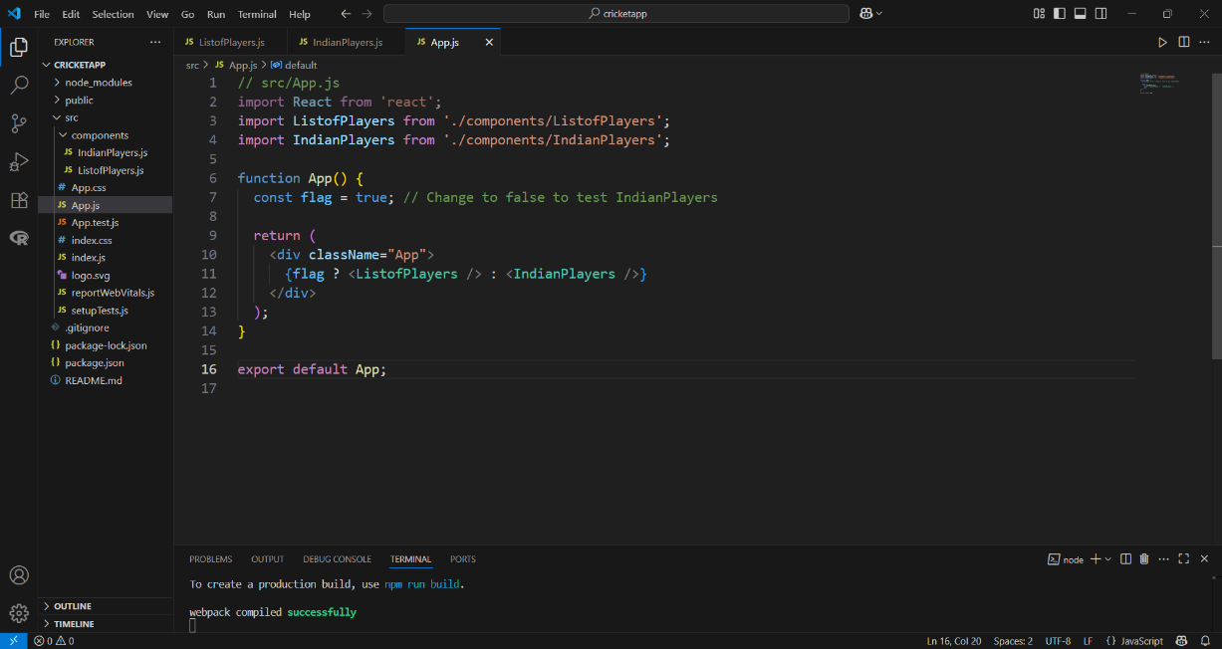

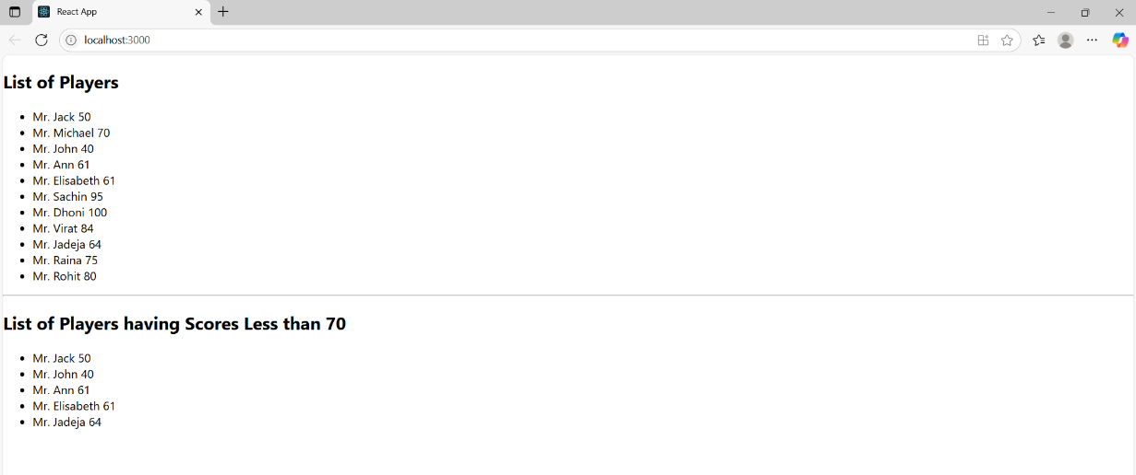

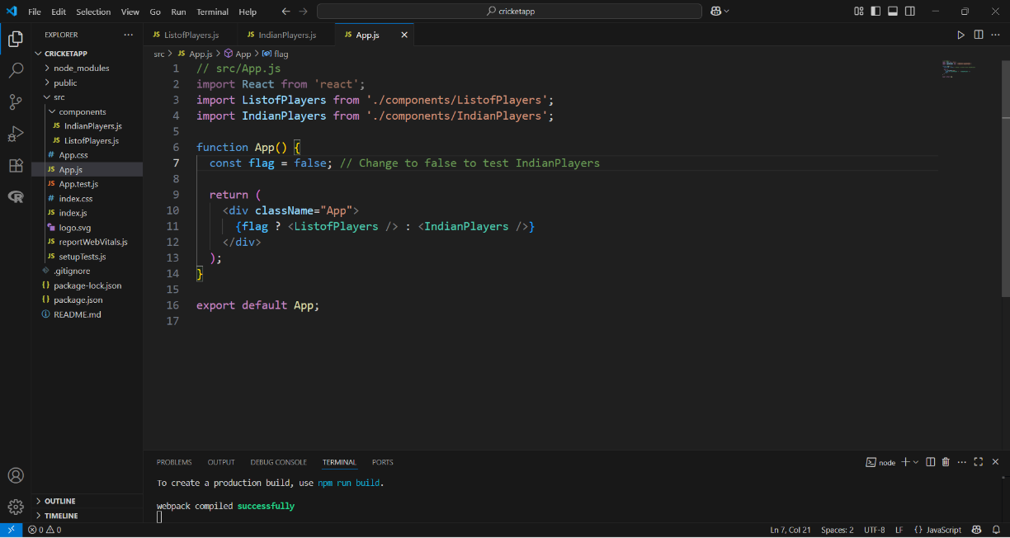

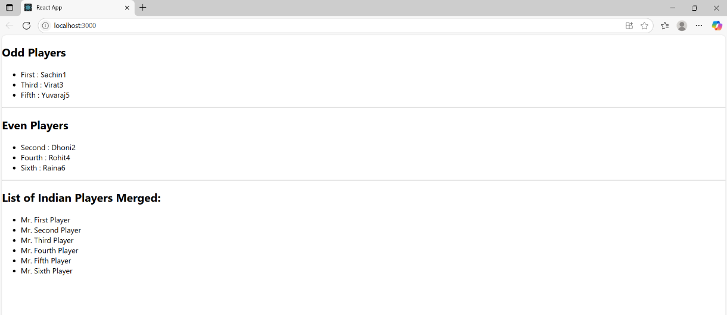

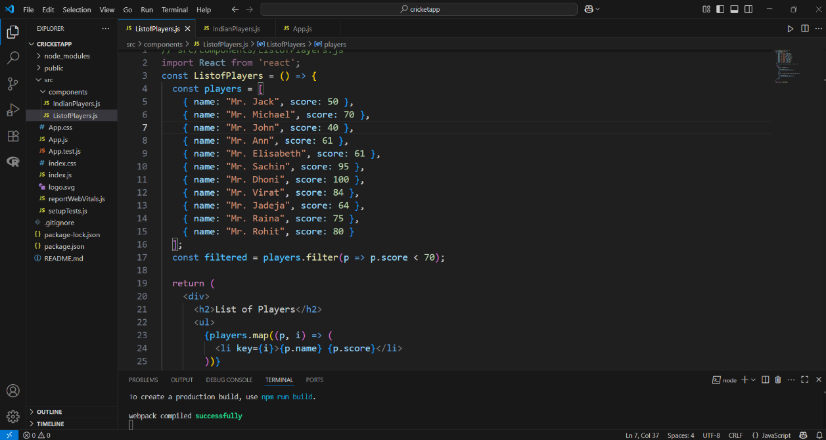

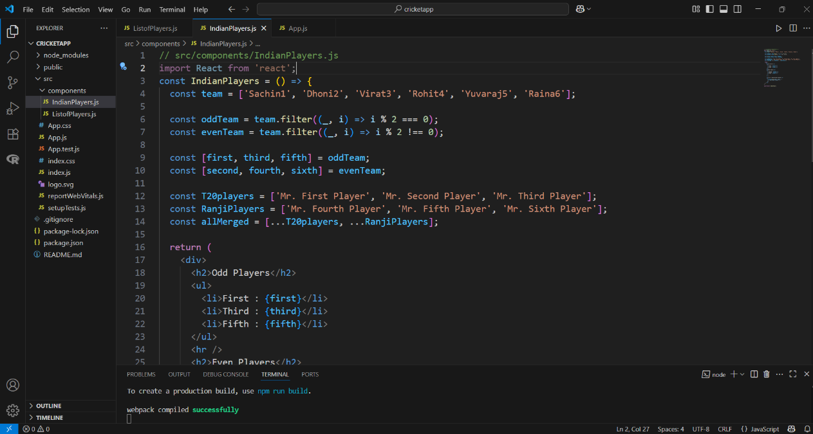

**BloggerApp:**

**CODE:**

**App.js:**

import React from 'react';

import BookDetails from './components/BookDetails';

import BlogDetails from './components/BlogDetails';

import CourseDetails from './components/CourseDetails';

import { books } from './data/books';

import { blogs } from './data/blogs';

import { courses } from './data/courses';

import './App.css';

function App() {

  return (

    <div className="container">

      <div className="section">

        <CourseDetails courses={courses} />

      </div>

      <div className="section">

        <BookDetails books={books} />

      </div>

      <div className="section">

        <BlogDetails blogs={blogs} />

      </div>

    </div>

  );

}

export default App;

**App.css:**

/* -------------------- */

/* Global & Container   */

/* -------------------- */

body {

  font-family: Arial, sans-serif;

  margin: 0;

  padding: 0;

}

.container {

  display: flex;

  justify-content: space-around;

  padding: 50px;

}

/* Each column/section */

.section {

  padding: 0 40px;

  width: 30%;

}

/* Green vertical line between sections (not on the first one) */

.section:not(:first-child) {

  border-left: 4px solid green;

}

/* Section Headings like Course Details, Book Details, Blog Details */

.section-title {

  font-size: 28px;

  font-weight: bold;

  margin-bottom: 25px;

}

/* -------------------- */

/* Course Details       */

/* -------------------- */

.course-item {

  margin-bottom: 30px;

}

.course-name {

  font-size: 30px;

  font-weight: bold;

  margin: 0 0 18px 0;

}

.course-date {

  font-size: 16px;

  font-weight: bold;

  margin: 0;

}

/* -------------------- */

/* Book Details         */

/* -------------------- */

.book-item {

  margin-bottom: 25px;

}

.book-name {

  font-size: 16px;

  font-weight: bold;

  margin: 8px 0 4px;

}

.book-price {

  font-size: 14px;

  font-weight: 600;

  margin-top: 20px;

}

.book-content {

  padding-left: 38px;

}

/* -------------------- */

/* Blog Details         */

/* -------------------- */

.blog-item {

  margin-bottom: 30px;

}

.blog-title {

  font-size: 26px;

  font-weight: bold;

  margin: 20px 0 8px;

}

.blog-author {

  font-size: 12px;

  font-weight: bold;

  margin: 20px 0 6px;

}

.blog-content {

  font-size: 12px;

  margin: 18px 0;

}

**CourseDetails.js:**

import React from 'react';

function CourseDetails({ courses }) {

  return (

    <div>

      <h2 className="section-title">Course Details</h2>

      {courses.map((course, index) => (

        <div className="course-item" key={index}>

          <div className="course-name">{course.name}</div>

          <div className="course-date">{course.date}</div>

        </div>

      ))}

    </div>

  );

}

export default CourseDetails;

**Courses.js:**

export const courses = [

  { name: "Angular", date: "4/5/2021" },

  { name: "React", date: "6/3/2021" }

];

**BookDetails.js:**

import React from 'react';

const BookDetails = ({ books }) => {

  return (

    <div>

      <h2 className="section-title">Book Details</h2>

      <div className="book-content">

        {books.map((book) => (

          <div key={book.id} className="book-item">

            <h3 className="book-name">{book.bname}</h3>

            <p className="book-price">{book.price}</p>

          </div>

        ))}

      </div>

    </div>

  );

};

export default BookDetails;

**Books.js:**

export const books = [

  { id: 101, bname: 'Master React', price: 670 },

  { id: 102, bname: 'Deep Dive into Angular 11', price: 800 },

  { id: 103, bname: 'Mongo Essentials', price: 450 },

];

**BlogDetails.js:**

import React from 'react';

const BlogDetails = ({ blogs }) => {

  return (

    <div>

      <h2 className="section-title">Blog Details</h2>

      {blogs.map((blog, index) => (

        <div key={index} className="blog-item">

          <h3 className="blog-title">{blog.title}</h3>

          <p className="blog-author">{blog.author}</p>

          <p className="blog-content">{blog.content}</p>

        </div>

      ))}

    </div>

  );

};

export default BlogDetails;

**BlogDetails.js:**

export const blogs = [

  {

    title: 'React Learning',

    author: 'Stephen Biz',

    content: 'Welcome to learning React!',

  },

  {

    title: 'Installation',

    author: 'Schwezdenier',

    content: 'You can install React from npm.',

  },

];

**Outputs:**

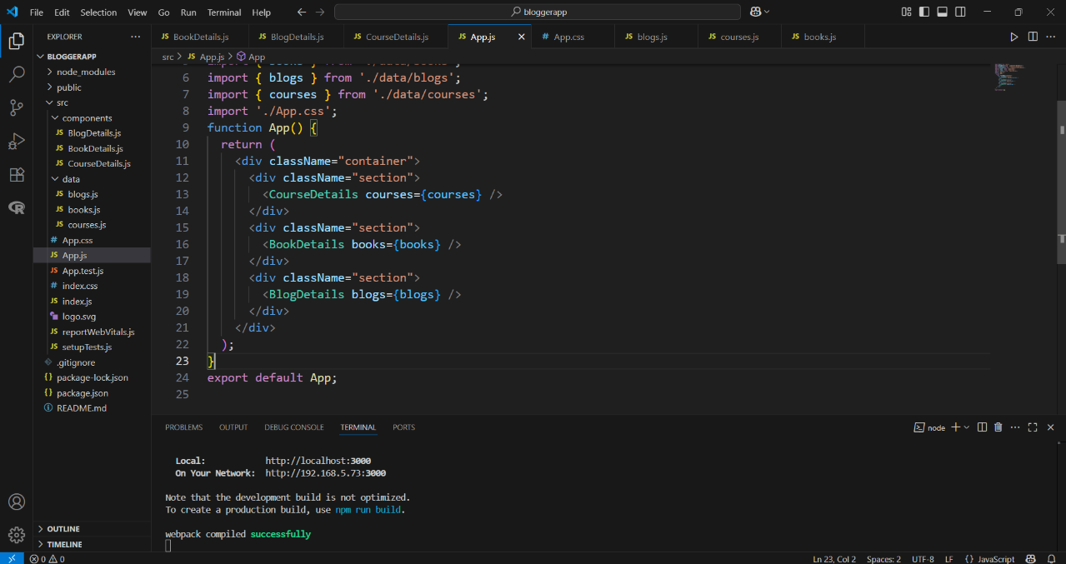

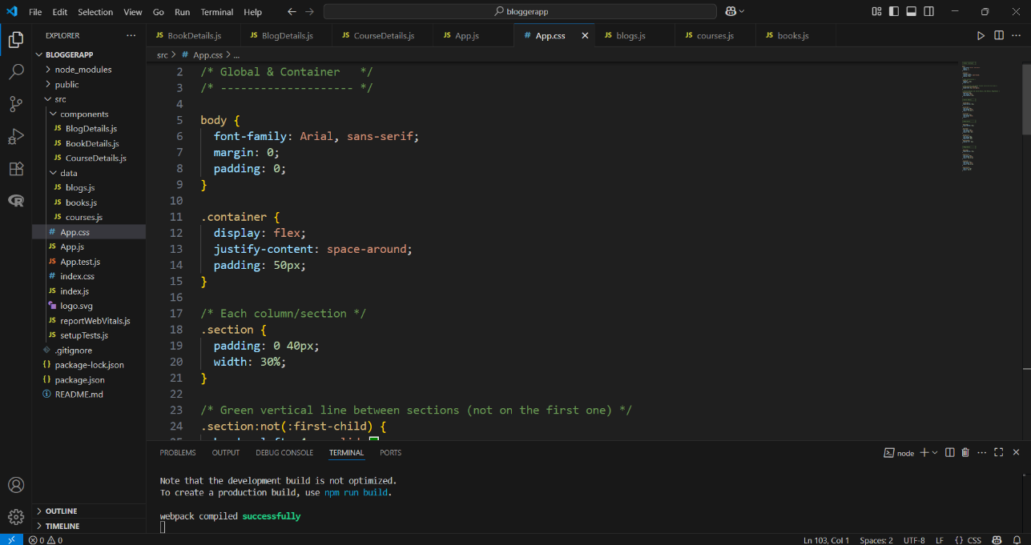

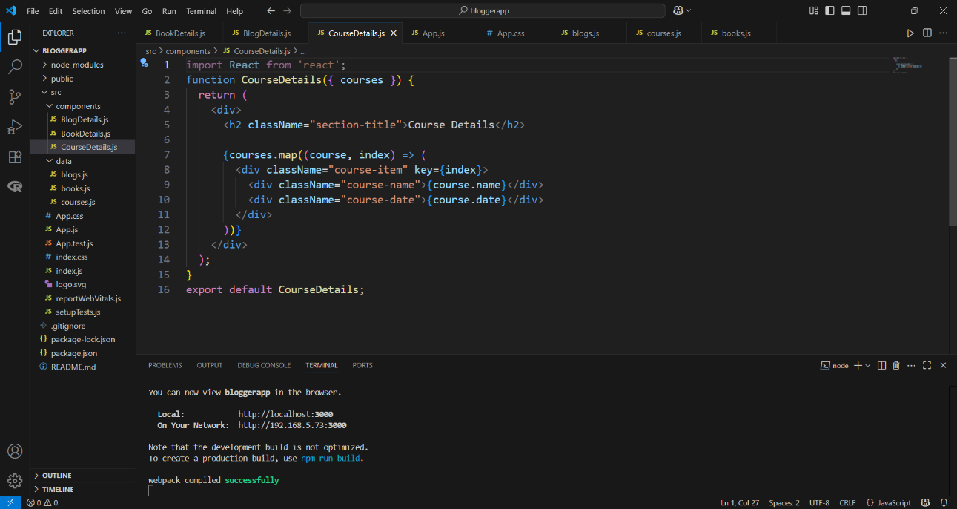

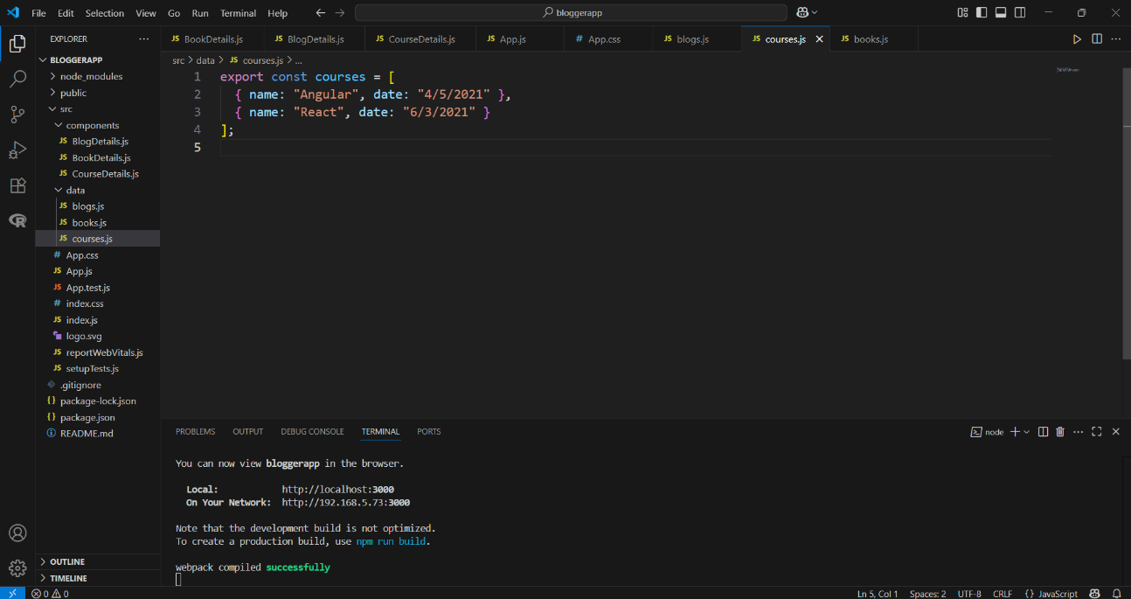

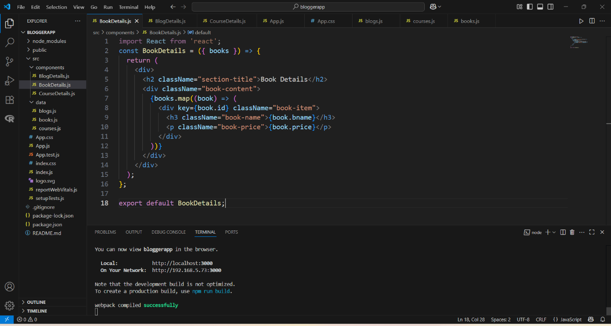

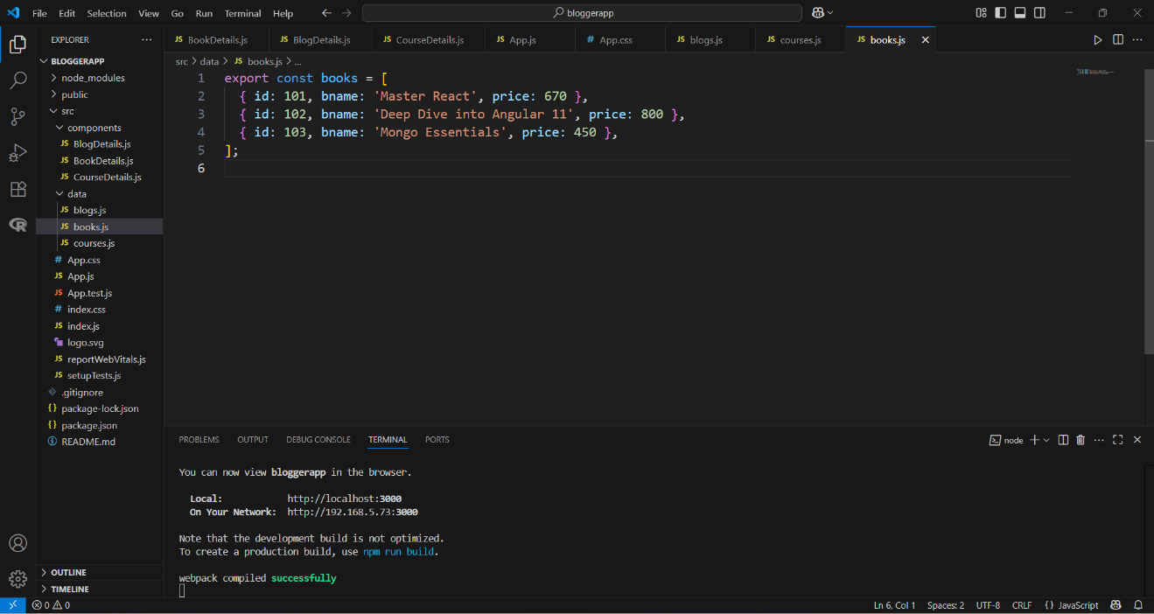

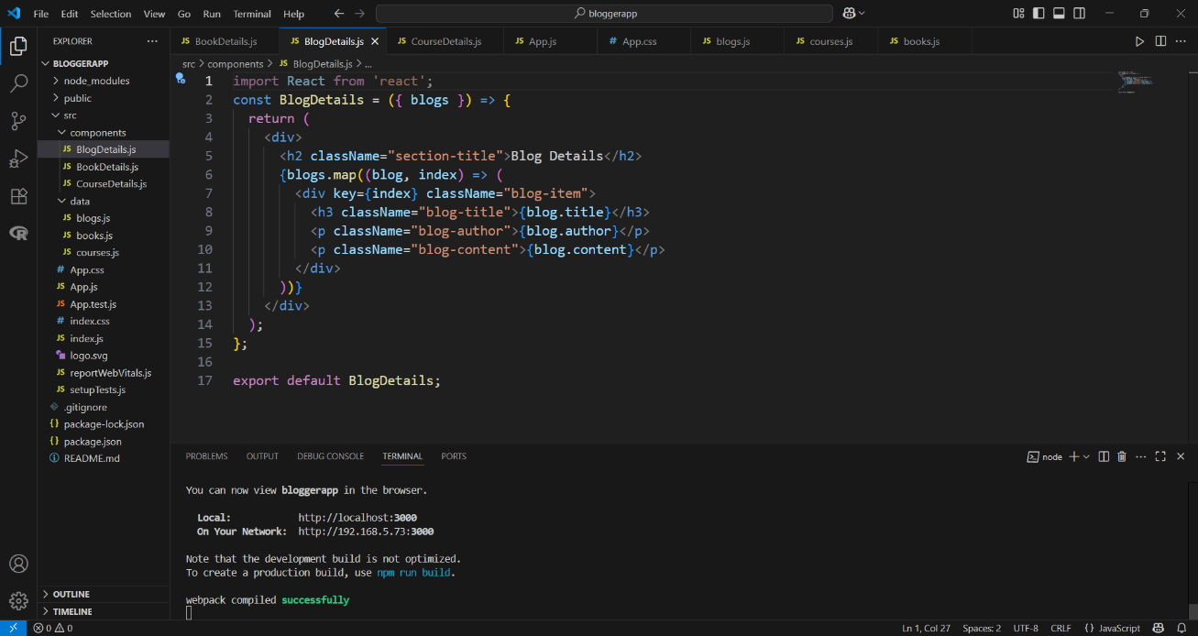

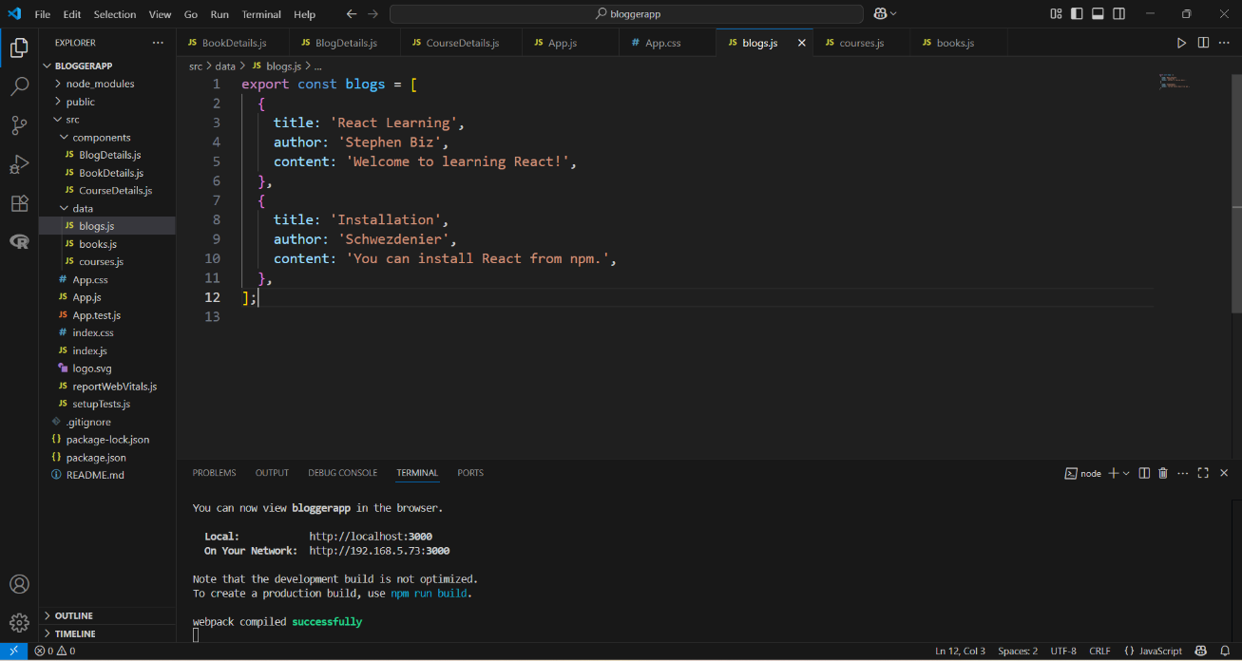

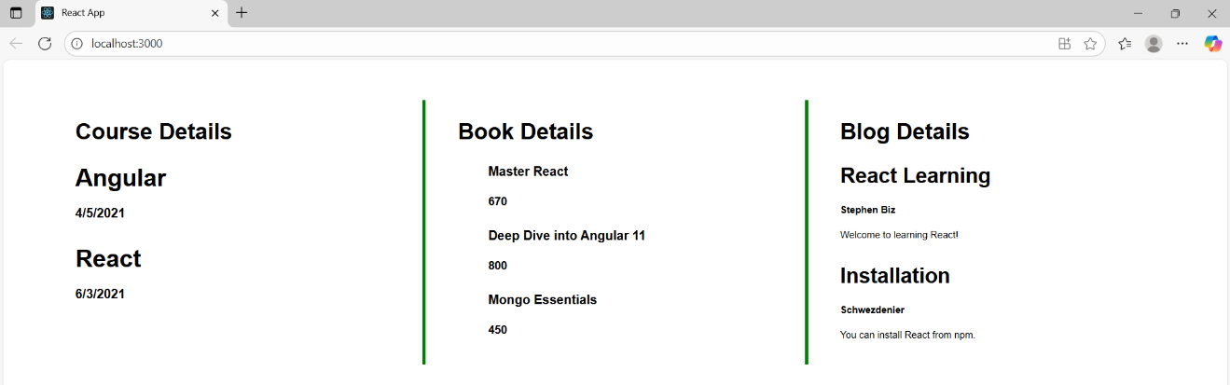

**CurrencyConvertor:**

**CODE:**

**App.js:**

import React, { useState } from 'react';

import CurrencyConvertor from './CurrencyConvertor';

function App() {

  const [count, setCount] = useState(1);

  const increment = () => {

    setCount(prev => prev + 1);

    sayHello();

  };

  const sayHello = () => {

    alert("Hello! This is a static message.");

  };

  const decrement = () => {

    setCount(prev => prev - 1);

  };

  const sayWelcome = (message) => {

    alert(message);

  };

  const handleClick = () => {

    alert("I was clicked");

  };

  return (

    <div style={{ margin: '20px', fontFamily: 'Arial' }}>

      <h3>{count}</h3>

      <div style={{ marginBottom: '10px' }}>

        <button onClick={increment}>Increment</button>

      </div>

      <div style={{ marginBottom: '10px' }}>

        <button onClick={decrement}>Decrement</button>

      </div>

      <div style={{ marginBottom: '10px' }}>

        <button onClick={() => sayWelcome("Welcome")}>Say welcome</button>

      </div>

      <div style={{ marginBottom: '10px' }}>

        <button onClick={handleClick}>Click on me</button>

      </div>

      <CurrencyConvertor />

    </div>

  );

}

export default App;

**CurrencyConverter.js:**

import React, { useState } from 'react';

import CurrencyConvertor from './CurrencyConvertor';

function App() {

  const [count, setCount] = useState(1);

  const increment = () => {

    setCount(prev => prev + 1);

    sayHello();

  };

  const sayHello = () => {

    alert("Hello! This is a static message.");

  };

  const decrement = () => {

    setCount(prev => prev - 1);

  };

  const sayWelcome = (message) => {

    alert(message);

  };

  const handleClick = () => {

    alert("I was clicked");

  };

  return (

    <div style={{ margin: '20px', fontFamily: 'Arial' }}>

      <h3>{count}</h3>

      <div style={{ marginBottom: '10px' }}>

        <button onClick={increment}>Increment</button>

      </div>

      <div style={{ marginBottom: '10px' }}>

        <button onClick={decrement}>Decrement</button>

      </div>

      <div style={{ marginBottom: '10px' }}>

        <button onClick={() => sayWelcome("Welcome")}>Say welcome</button>

      </div>

      <div style={{ marginBottom: '10px' }}>

        <button onClick={handleClick}>Click on me</button>

      </div>

      <CurrencyConvertor />

    </div>

  );

}

export default App;

**Outputs:**

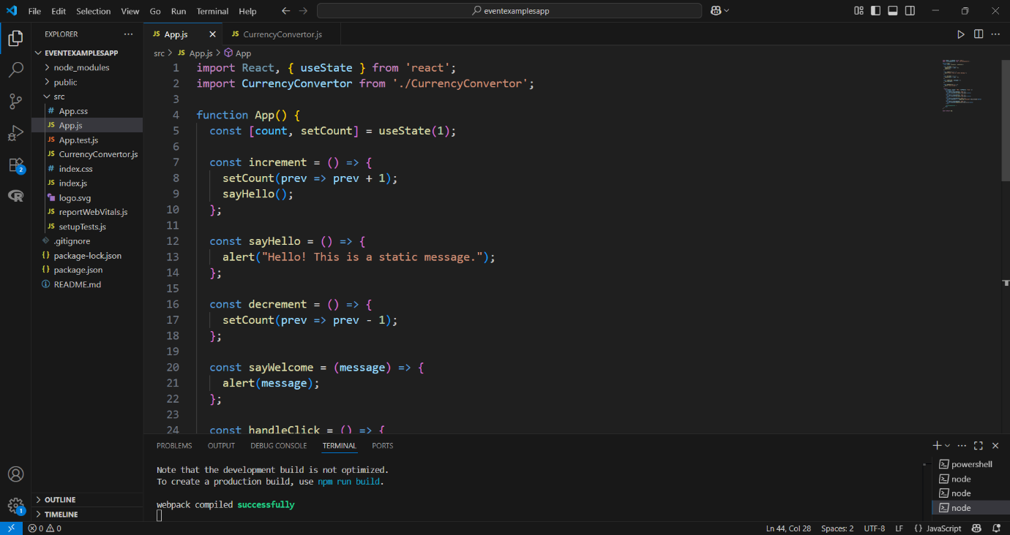

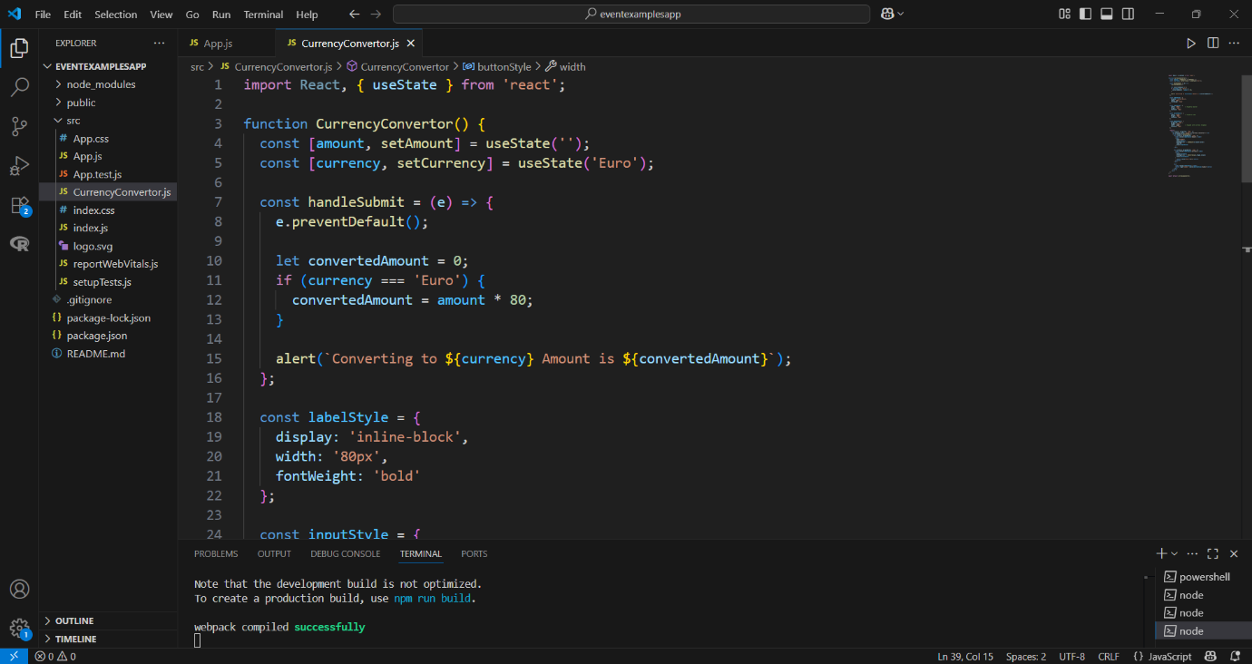

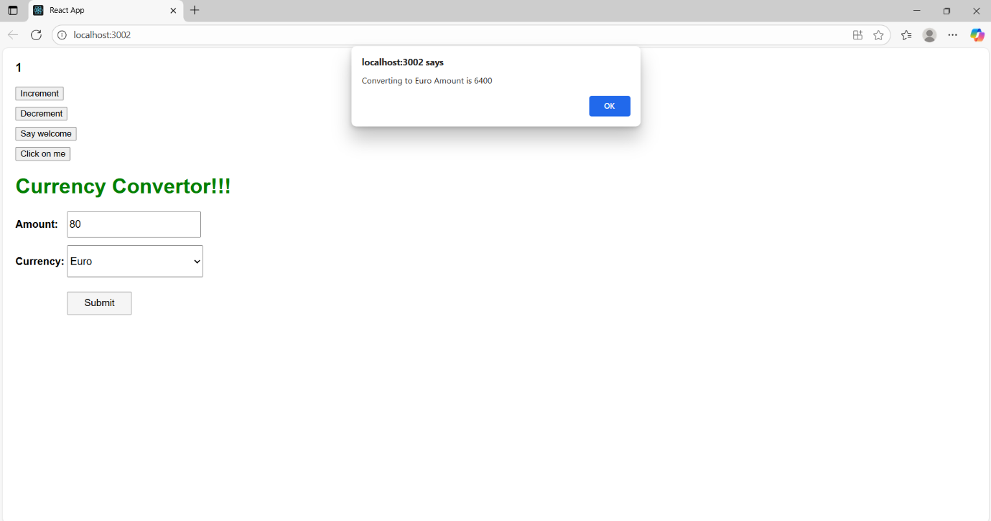

**OfficeSpaceRentalApp:**

**CODE:**

**App.js:**

import React from 'react';

import officeImage from './office.jpg'; // Ensure this image is inside the src folder

function App() {

  const officeSpaces = [

    {

      name: 'DBS',

      rent: 50000,

      address: 'Chennai'

    }

  ];

  return (

    <div style={{ fontFamily: 'Arial, sans-serif', padding: '30px' }}>

      {/* Heading */}

      <h1 style={{ textAlign: 'center', fontWeight: 'bold', fontSize: '30px' }}>

        Office Space, at Affordable Range

      </h1>

      {/* Image and details block */}

      <div style={{ marginLeft: '880px', marginTop: '30px' }}>

        <img

          src={officeImage}

          alt="Office"

          width="250"

          style={{

            borderRadius: '10px',

            display: 'block',

            marginBottom: '20px'

          }}

        />

        {officeSpaces.map((office, index) => (

          <div key={index} style={{ lineHeight: '2' }}>

            <h1 style={{ fontSize: '30px', fontWeight: 'bold', margin: '10px 0' }}>

              Name: {office.name}

            </h1>

            <p

              style={{

                color: office.rent < 60000 ? 'red' : 'green',

                fontSize: '22px',

                fontWeight: 'bold',

                margin: '10px 0'

              }}

            >

              Rent: Rs. {office.rent}

            </p>

            <p style={{ fontSize: '22px', fontWeight: 'bold', margin: '10px 0' }}>

              Address: {office.address}

            </p>

          </div>

        ))}

      </div>

    </div>

  );

}

export default App;

**App.css:**

.App {

  text-align: center;

  margin-top: 20px;

  font-family: Arial, sans-serif;

}

.textRed {

  color: red;

  font-weight: bold;

}

.textGreen {

  color: green;

  font-weight: bold;

}

.office-details {

  margin-top: 20px;

}

**Outputs:**

